EXPLORE EUROPEAN CULTURE AND HISTORY SOCIAL MEDIA CAMPAIGN

PARTNER CONTENT
Week of February 4, 2019

HOW TO USE THIS CONTENT

The following social media posts are shared with you as part of the World Heritage Journeys of Europe’s Explore European History and Culture social media campaign. The campaign is intended to generate awareness for European cultural heritage, promote responsible tourism to World Heritage sites, and develop our contact database of potential travellers for email marketing later in the year.

Each week during the month of February, UNESCO and National Geographic will give away a free copy of the World Heritage Journeys: Explore European History and Culture special publication. Anyone who goes to www.visitworldheritage.com/sweepstake during the month of February will have a chance to enter to be randomly selected to win.

We invite you to help the World Heritage Journeys programme promote this giveaway by posting about the campaign on your social media channels. All you need to do is copy and paste the suggested social media posts below into your social media channels. You are welcome to edit or customise the posts.

SOCIAL MEDIA POST #1

<<<Name of your World Heritage site>>> is excited to be featured in a new special publication from @NationalGeographic and @UNESCO, #visiteuworldheritage. You can enter to win a free copy by visiting www.visitworldheritage.com/sweepstake.

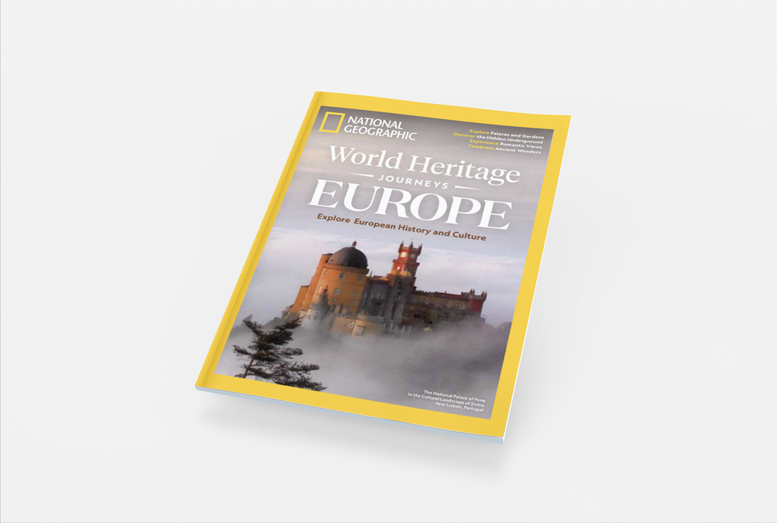

Reminder:

Facebook: @UNESCO
Twitter: @UNESCO
Instagram: @unesco

Facebook: @natgeo
Twitter: @NatGeo
Instagram: @natgeo

SOCIAL MEDIA POST #2

Are you dreaming of visiting <<<insert name of your World Heritage site>>>? Start planning your trip with a free copy of Experience European History and Culture, a limited edition publication from @UNESCO and @NationalGeographic. #visiteuworldheritage. www.visiteuworldheritage.com/sweepstake

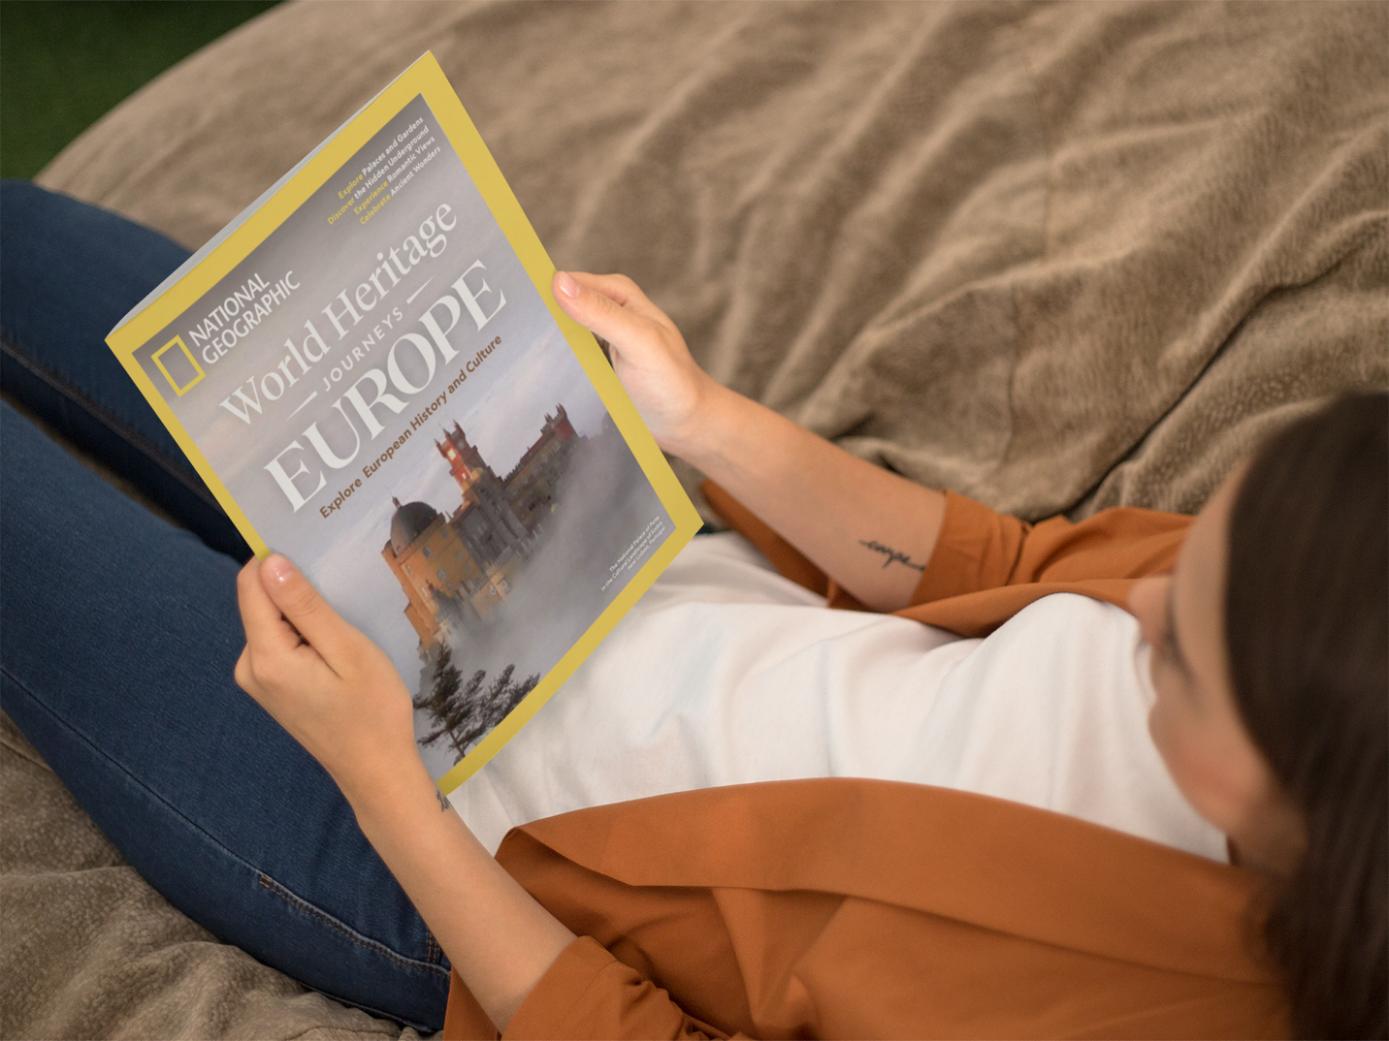

SOCIAL MEDIA POST #3

Start planning your World Heritage Journey with a free guide to some of Europe’s most celebrated World Heritage sites. Every week in February, @UNESCO is giving away a free @NationalGeographic special edition. Get yours today! #visiteuworldheritage www.visiteuworldheritage.com/sweepstake

