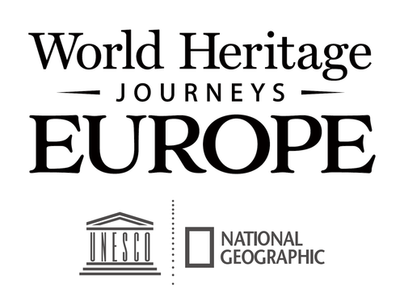

THE CULTURAL TOURISM DECLARATION

WHEREAS, our approach to sustainable tourism development focuses on the diversity of the cultural, historic and scenic assets of _____________.

WHEREAS, our approach to sustainable tourism development encourages both citizens and visitors to get involved in the protection of cultural heritage, and

WHEREAS our approach to sustainable tourism development will help build a sense of local identity and pride, highlighting what is authentic and unique to ____________________.

THE UNDERSIGNED parties to this Declaration commit to support the following policy guidelines to ensure proper management and recognition of the important and mutually reliant relationship between tourism and culture for the economic and social sustainability of our destination.

Integrity of place: Enhance geographical character by developing and improving it in ways distinctive to the locale, reflective of its natural and cultural heritage, so as to encourage market differentiation and cultural pride.

International codes: Adhere to the principles embodied in the World Tourism Organization’s Global Code of Ethics for Tourism and the Principles of the Cultural Tourism Charter established by the International Council on Monuments and Sites (ICOMOS).

Market selectivity: Encourage growth in tourism market segments most likely to appreciate, respect, and disseminate information about the distinctive assets of the locale.

Market diversity: Encourage a full range of appropriate food and lodging facilities, so as to appeal to the entire demographic spectrum of the cultural tourism market and so maximize economic resiliency over both the short and long term.

Tourist satisfaction: Ensure that satisfied, excited travellers bring new vacation stories home and send friends off to experience the same thing, thus providing continuing demand for the destination.

Community involvement: Base tourism on community resources to the extent possible, encouraging local small businesses and civic groups to build partnerships to promote and provide a distinctive, honest visitor experience and market their locales effectively. Help businesses develop approaches to tourism that build on the area’s nature, history and culture, including food and drink, artisanry, performance arts, etc.

Community benefit: Encourage micro- to medium-size enterprises and tourism business strategies that emphasize economic and social benefits to involved communities, especially poverty alleviation, with clear communication of the destination stewardship policies required to maintain those benefits.

Protection and enhancement of destination appeal: Encourage businesses to sustain natural habitats, heritage sites, aesthetic appeal, and local culture. Prevent degradation by keeping volumes of tourists within maximum acceptable limits. Seek business models that can operate profitably within those limits. Use persuasion, incentives, and legal enforcement as needed.

Land use: Anticipate development pressures and apply techniques to prevent undesired overdevelopment and degradation. Contain resort and vacation-home sprawl so as to retain a diversity of natural and scenic environments and ensure continued resident access to waterfronts. Encourage major self-contained tourism attractions, such as large-scale theme parks and convention centers unrelated to character of place, to be sited in needier locations with no significant ecological, scenic, or cultural assets.

Conservation of resources: Encourage businesses to minimize water pollution, solid waste, energy consumption, water usage, landscaping chemicals, and overly bright nighttime lighting. Advertise these measures in a way that attracts the large, environmentally sympathetic tourist market.

Planning: Recognize and respect immediate economic needs without sacrificing long-term character and the cultural tourism potential of the destination. Where tourism attracts in-migration of workers, develop new communities that themselves constitute a destination enhancement. Strive to diversify the economy and limit population influx to sustainable levels. Adopt public strategies for mitigating practices that are incompatible with cultural tourism and damaging to the image of the destination.

Interactive interpretation: Engage both visitors and hosts in learning about the place. Encourage residents to show off the natural and cultural heritage of their communities, so that tourists gain a rich experience and residents develop pride in their locales.

Evaluation: Establish an evaluation process to be conducted on a regular basis by an independent panel representing all stakeholder interests, and publicize evaluation results.

___________________________________ __________________________________ __________________________________
Name and Title of Signatory Name and Title of Signatory Name and Title of Signatory
Heritage Manager Organization Name Destination Management Organisation Name Local Elected Official

<Insert Logo> <Insert Logo> <Insert Logo>

