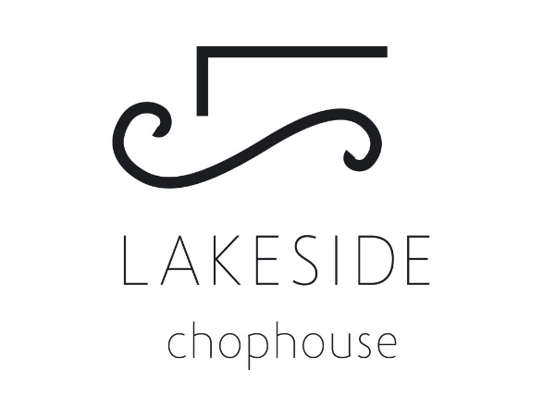

TASTE OF WATERTON
Feature Menu

Little Qualicum Blue Cheese Croquette 16
Pulled beef short rib, peppercorn demi

Tandoori Chicken Flatbread 18
Tandoori curry chicken, roasted garlic, chickpea, bell pepper, scallion, cilantro yogurt on naan

Wild Rose Farm (Fort Macleod) Alberta Premium Angus Beef Rib-eye 10oz 48
Antibiotic & hormone free beef, wild mushrooms herb gnocchi, seasonal vegetables, demi glace

Brome Lake Duck Breast 38
Brome Lake Duck Breast slow roasted in a thyme au jus. Served with fingerling potatoes, duck confit, green beans & pancetta

Dark Chocolate Marquise 14
Almond genoise cake, dark chocolate mousse, chantilly cream

Menu created by Chef Brian Long

